Annual session 2019
30 May, 3-4 and 6-7 June 2019, New York
Item 11 of the provisional agenda
United Nations Office for Project Services

The governance structure of the United Nations Office for Project Services

Proposal to establish a UNOPS client board to replace the Policy Advisory Committee

Summary
The present report presents to the Executive Board the Secretary-General’s decision to establish a UNOPS client board to replace the Policy Advisory Committee established by the Secretary-General in 2008.
The purpose of the proposal is twofold. On the one hand, it is to eliminate any potential, actual, or perceived infringement on the role of the Executive Board in the oversight of, and UNOPS accountability for, strategy and policy. On the other, it is to support the ambition of UNOPS to engage more strategically with partners by establishing a regular interface for exchange of advice and for deepening focused collaborative strategic partnerships between UNOPS and its partners in the United Nations system and beyond.
Elements of a decision
The Executive Board may wish to: (a) take note of the Secretary-General’s decision to establish a UNOPS client board to replace the Policy Advisory Committee, pursuant to internal consultation and a review by the Joint Inspection Unit; (b) recognize that, in the context of the Secretary-General’s management reform, the client board can play an important role as a forum for further deepening focused collaborative strategic partnerships for efficiency and effectiveness between UNOPS and the United Nations system, including in the areas of procurement and infrastructure; (c) request relevant United Nations entities and other partners, upon invitation by the Executive Director, to identify senior-level representatives to participate in the client board; and (c) note that references to the policy advisory committee in the UNOPS financial regulations and rules shall henceforth imply the client board.

A. Introduction
1. This report presents the Secretary-General’s decision to establish a UNOPS client board to replace the Policy Advisory Committee established by the Secretary-General in 2008. The decision concludes the internal consultation requested by the Executive Board and has been informed by a review of the Joint Inspection Unit.
2. The purpose of the proposal is twofold. On the one hand, it is to eliminate any potential, actual, or perceived infringement on the role of the Executive Board role in the oversight of, and UNOPS accountability for, strategy and policy. On the other, it is to support the ambition of UNOPS to engage more strategically with partners by establishing a regular interface for exchanging advice and deepening focused collaborative strategic partnerships with its partners in the United Nations system and beyond.
B. Background
3. In 1995, in accordance with Executive Board decision 94/12, UNOPS became a separate and identifiable entity pursuant to General Assembly decision 48/501. In 2010, General Assembly resolution 65/176 reconfirmed past decisions of the Executive Board. Since then, the Executive Board has through a number of decisions ensured the establishment of solid mandate and governance arrangements for the organization.
4. In its decision 2017/26, the Executive Board endorsed the UNOPS strategic plan, 2018-2021, recognizing its solid foundation in Member State decisions, policy guidance and international agreements, and the needs of people and countries, including in the most fragile situations. The Board expressed its appreciation of intention of UNOPS to engage more strategically with governments and other partners, and urged entities of the United Nations system to recognize the comparative advantages and technical expertise of UNOPS and to engage in collaborative strategic partnerships for efficiency and effectiveness, including at the country level.
5. Pursuant to its strategic plan, UNOPS is mandated to expand implementation capacity across peace and security, humanitarian, and development efforts, including through capacity development activities. Through its project services it supports governments, the United Nations, and other partners in achieving Member States’ global goals and local objectives for people and countries. UNOPS is an operational resource for Member States and the Secretary-General.
6. UNOPS is a strong proponent of the common principles that guide United Nations system collaboration in implementing the 2030 Agenda for Sustainable Development, including its emphasis on country-led, evidence-based and results-focused approaches; the prominence of expertise over exclusivity; and the need to ensure appropriate arrangements for operational support and effective service delivery. UNOPS is committed to United Nations harmonization and simplification of business processes, including those supporting the Executive Board, and subsidiary committees advising the Executive Director.
C. The Policy Advisory Committee in the context of the UNOPS governance structure
7. In its decision 2008/35, the Executive Board recognized the Secretary-General’s establishment of the UNOPS Policy Advisory Committee, as laid out in ‘The governance structure of United Nations Office for Project Services: Proposal to realign the Management Coordination Committee within the current governance arrangements of UNOPS’ (DP/2008/52).
8. Established by the Secretary-General, the envisaged purpose of the Policy Advisory Committee was provision of United Nations policy guidance to the UNOPS Executive Director, who at the time was appointed at the Assistant Secretary-General level. Its role was advisory in nature and its functions were to: (a) provide guidance to UNOPS in developing its strategy and business plan consistent with the self-financing basis; and (b) provide guidance on the relationships between UNOPS, and United Nations departments, offices and funds, programmes, and agencies at the organizational level and in the context of United Nations country teams under the resident/humanitarian coordinators.
9. The terms of reference for the Policy Advisory Committee were endorsed by its members at the inaugural meeting on 22 May 2009. The members included the Administrator of the United Nation Development Programme, the Chair of the High-Level Committee on Management, the Under-Secretary-General for Management, the Under-Secretary-General for Field Support, and the Under-Secretary-General for Humanitarian Affairs and Emergency Relief Coordinator. The United Nations Legal Counsel could participate in meetings ex-officio, but could not be nominated chair. The UNOPS Executive Director was an ex-officio member, and the chair was appointed by members on an annual rotational basis.
10. Since the inaugural meeting of the Policy Advisory Committee, the UNOPS governance structure and the formal role of UNOPS in United Nations management coordination have evolved. The Executive Director is now appointed as Under-Secretary-General and participates in the Secretary-General’s Senior Management Meeting. In early 2016, the Executive Director was recognized and as a full and equal member of the United Nations System Chief Executives Board for Coordination.
11. In its decision 2015/12, the Executive Board recalled decisions 2008/35 and 2009/4. To promote greater efficiency in UNOPS operations, the Board requested the Executive Director to consult with the Secretary-General on the future role of the Policy Advisory Committee vis-à-vis that of the Executive Board regrading oversight and policy guidance to UNOPS, recognizing the considerable changes made to the governance structure of UNOPS since 2009 and the evolution of its role and mandate.
12. From September 2015 to February 2019, the UNOPS Executive Director engaged in consultation with representatives of the Executive Office of the Secretary-General, including the Deputy Secretary-General and the Chef de Cabinet. The process included solicitation of input and perspectives on the relevance and future role of the Policy Advisory Committee from the Chair and members of committee. The outcome of the consultation was a recommendation to the Secretary-General that the Policy Advisory Committee be replaced with a UNOPS client board to provide a regular interface for exchange of advice and a deepening of focused collaborative strategic partnerships between UNOPS and its partners in the United Nations system and beyond.
13. In its 2018 review of management and administration in UNOPS (JIU/REP/2018/3), the Joint Inspection Unit recommended that the Executive Board reiterate the need to expedite the issuance of a decision on the future of the Committee, and suggested that consideration be given to further examining the proposal for a new committee with a view to adding value by broadening its membership.
14. In its 2018 review of opportunities to improve efficiency and effectiveness in administrative support services by enhancing inter-agency cooperation (JIU/REP/2018/5), the Joint Inspection Unit recommended that the Secretary-General work with the Executive Director of UNOPS to ensure that the capacities of the Office to provide services are also fully considered in the formulation of administrative support service arrangements.
15. During the consultation process it was emphasized that the UNOPS client board could play an important role in supporting the Secretary-General’s management reform. With its focus on operations, the client board could provide the Department of Operations Support – the operational arm of the new management architecture of the Secretariat – with a strategic interface on project services and implementation, including ensuring ‘best value for money’ in procurement and technical expertise for resilient and sustainable infrastructure. At the same time, the client board would provide the United Nations Department of Management Strategy, Policy and Compliance with a strategic interface in relation to inter-agency coordination of efficient, effective project services and implementation.
16. The Secretary-General concluded the consultations on 19 March 2019, informing the UNOPS Executive Director of his decision to establish a UNOPS client board to replace the Policy Advisory Committee established in 2008. He emphasized the advantage of having the Department of Operations Support and the United Nations Department of Management Strategy, Policy and Compliance as members of the client board.
D. Establishment of a UNOPS client board
17. In his note, the Secretary-General laid out the purpose, role, functions, membership, and operating modalities of the UNOPS client board. They are summarized in the following paragraphs.
18. The purpose of the UNOPS client board will be to serve as an advisory body to the Executive Director, providing a forum for the deepening of focused collaborative strategic partnerships.
19. With a focus on operations, the role of the client board will be to provide input and feedback on UNOPS performance from a partner perspective. It can identify opportunities and challenges, provide early warning of potential risks, inform possible corrective actions, and advice on strategic measures for the medium and longer term.
20. The functions of the client board will be to:
(a) Ensure a proper flow of information from UNOPS partners to provide feedback on services rendered by UNOPS and concerns that partners may have in this regard;
(b) Provide a channel of communication from UNOPS to its partners to facilitate an understanding of UNOPS existing and emerging services and corresponding policies;
(c) Identify ways in which partners and UNOPS can jointly enhance the impact of their work in support of achieving the sustainable development goals;
(d) Promote the dissemination of lessons learned and new approaches as they are developed; and
(e) Make recommendations to UNOPS with a view to enhancing effectiveness and responsiveness in its activities.
21. The client board will draw its membership from current and potential UNOPS partners in the United Nations system and beyond, although not all current and potential partners need be included. In accordance with the UNOPS mandate, members can be draw from a broad constituency: governments (recipient and donor), the United Nations system, intergovernmental institutions, international and regional financing institutions, foundations, and possibly non-governmental and private sector organizations with whom UNOPS partners. The membership will expand and contract over time. The Executive Director will nominate members by invitation, which will not be confined to principals of partner entities. Indeed, the preference will be that partners be represented by individuals who have regular interaction and direct experience with UNOPS activities as these evolve, also having the appropriate level of authority to represent the perspective of the partner.
22. Serving as the client board secretariat, the UNOPS Executive Director will convene an annual meeting of the client board, to be held in two segments:
(a) A first segment, chaired by a representative of the Department of Operations Support, for United Nations partners only; and
(b) A second general segment for all partners, chaired by the UNOPS Executive Director.
23. For each segment, the Executive Director will invite partners to submit topics for discussion at the annual meeting. The meeting will normally be convened around the time of the first regular session of the UNOPS Executive Board so that the Executive Director can take the discussions into consideration in time for the preparation of the annual report, which is normally presented at the annual session of the Executive Board.

Annex 1: Note from the Secretary-General dated 19 March 2019
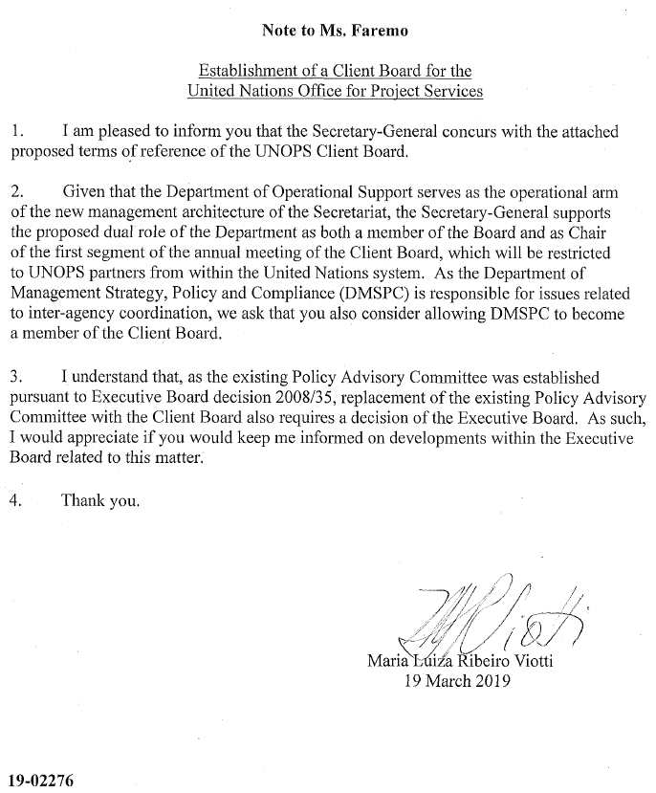
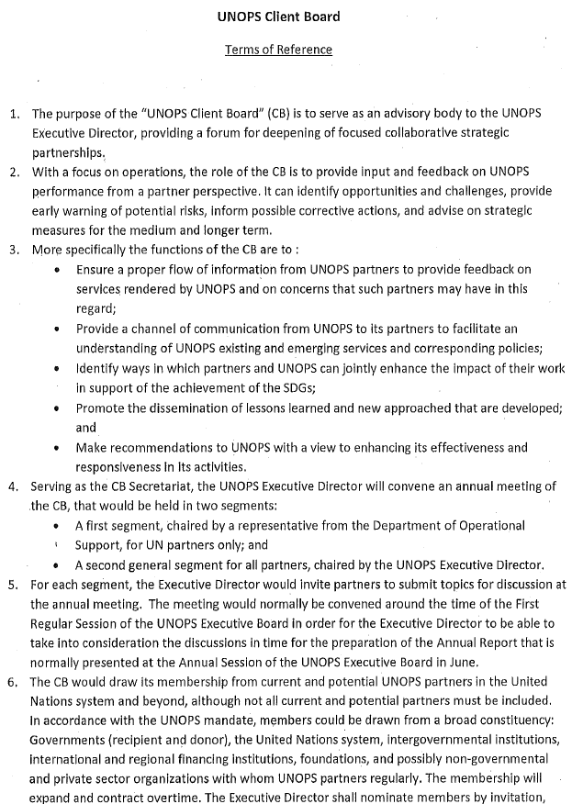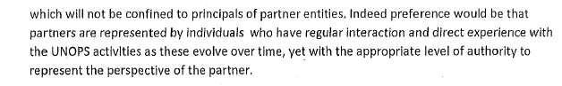
Annex 2: Terms of Reference for the Policy Advisory Committee
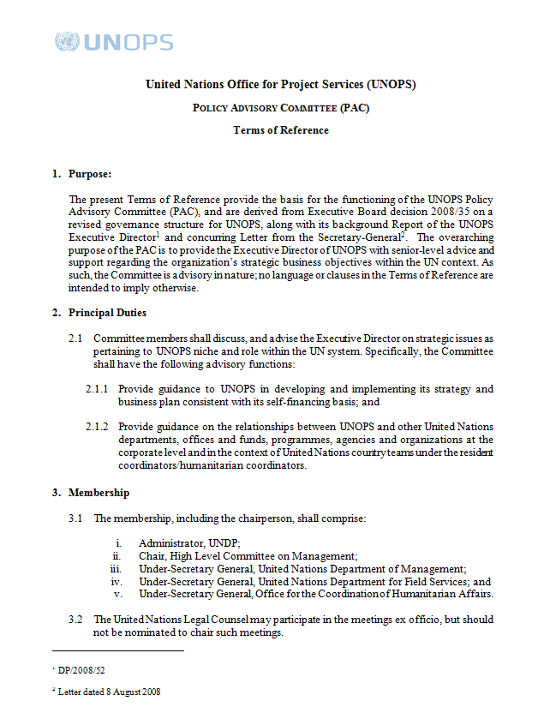
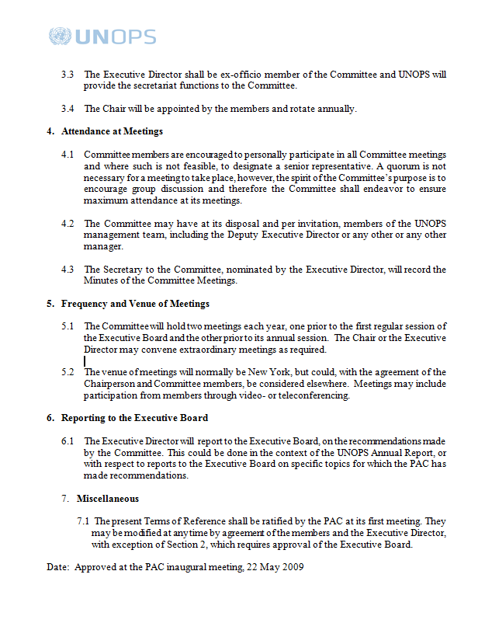

In the UNOPS financial regulations and rules the policy advisory committee is referenced in article 4, rule 104.04. In accordance with the UNOPS legislative framework, financial regulations are established by the Executive Board, whereas financial rules are promulgated by the Executive Director.
Executive Board decision 2015/12
Review of management and administration in the United Nations Office for Project Services (JIU/REP/2018/3)
Key decisions include 2008/35, 2008/37, 2009/4, 2009/25, 2010/21, 2012/5, 2012/24, 2013/23, 2015/4, 2015/12, 2016/12, 2016/19, 2017/16 and 2017/26.
The UNOPS strategic plan, 2018-2021, DP/OPS/2017/5, paragraph 2
Ibid., paragraph 94
JIU/REP/2018/3, paragraphs 18-19
JIU/REP/2018/5, recommendation 8
Annex 1
Ibid.

