Annex I.

Methodological note on the UNOPS management results and budget framework

A. Introduction
1. The management results framework forms the results-based budgeting element of the UNOPS budget estimates, 2018-2019. The development of the framework was informed by extensive consultations with UNOPS business units in terms of management results ambition for the biennium, in line with UNOPS contribution goals as described in UNOPS strategic plan for 2018-2021. The process was informed by the outcome of the business and work planning process for 2017 and the ongoing efforts of embedding Global Reporting Initiative standards into UNOPS reporting.

B. Achievement of management results tracked through UNOPS balanced scorecard
2. The four management goals, articulated in the strategic plan, 2018-2021, provide direction to how UNOPS ensures the viability of its self-financing business model, and reflect the four perspectives (partners, people, process, and finance) of the UNOPS balanced scorecard, a core management tool used to drive strategic alignment, performance and maturity in all UNOPS business units.
Table 1. The partners perspective: partner value
Balanced scorecard perspective | Management  goal | Driver | Performance indicator | Baseline | Target  2018-2019
Partners | A. Partner value | A1.  Manage partner value | Share of relevant UNOPS projects reporting positive impacts on local economies | 54%  (2016) | 60%
 |  |  | Share of relevant UNOPS projects reporting implementation of capacity building initiatives in project delivery | 55%  (2016) | 60%
 |  |  | Share of relevant UNOPS projects reported with local community  engagement, impact assessment, and development programs | 60%  (2016) | 65%
 |  |  | Share of UNOPS relevant new infrastructure implementation projects  that include risk informed effective design and implementation  considerations that contribute to resilient outcomes | Not available | 100%
 |  |  | Expansion of the UNOPS concept of packaged management solutions to partners, beyond HR services, through a harmonized corporate approach | $117 million  (2016, HR services) | 10%
 |  |  | Share of UNOPS projects that are managed in accordance with a standardised plan to track for cost and schedule and for which risks are effectively managed to reduce exceptions | Not available  (2016) | 100%
 |  |  | Overall partner satisfaction | 83%  (average 2014-2016) | 85%
 |  |  | Willingness of UNOPS partners to recommend UNOPS services  (Net Promoter Score, NPS) | 33%  (average 2014-2016) | 35%
Partners | A. Partner value | A2.  Partner for knowledge and effect | Share of UNOPS procurement with registered local suppliers in  developing and fragile states | 52%  (2016) | 60%
 |  |  | Increase in new and extended partner agreements from global partners supported by liaison offices | $956 million  (average 2014-2016) | 10%
 |  |  | UNOPS contribution to procurement collaboration across UN agencies (collaborative procurement) | 24%  (2016) | 30%
 |  | A3. Communicate contribution of value | UNOPS Annual Report to the Executive Board compliant with Global Reporting Initiative (GRI) standards | 100%  (2016) | 100%
 |  |  | UNOPS compliance with IATI standards | 30%  (2016) | 100%
 |  |  | Average number of monthly visits to UNOPS public website | 81,636  (2016) | 85,500
 |  |  | Share of UNOPS public website content available in all  official UNOPS languages | 75%  (2016) | 80%
 |  |  | Individuals subscribing to UNOPS communication channels | 150,000  (2016) | 250,000
Table 2. The people perspective: people excellence
BSC Perspective | Management  goal | Driver | Performance indicator | Baseline | Target  2018-2019
People | B. People excellence | B1.  Embrace  a culture founded in United Nations values and principles | Women in senior positions  (ICSC-11 and above) | 25%  (2016) | 43%
 |  |  | Women in UNOPS workforce  (UNOPS personnel only) | 37%  (2016) | 50%
 |  |  | Share of personnel from global South in international positions | 42%  (2016) | 50%
 |  |  | Share of national professional positions in all professional positions  (excluding Copenhagen, Geneva, New York duty stations) | 47%  (2016) | 65%
 |  | B2.  Attract, recognize and develop talent | Overall personnel engagement | 4.16  (2016) | 4.06
 |  |  | Personnel performance appraisal completion rate | 91%  (2016) | 90%
 |  |  | Talent benches established for business critical roles,  which are actively in use | 100%  (7 of 7 in 2016) | 100%
 |  |  | UNOPS annual expenditure towards learning activities of its personnel com-pared to that of international best practices of high performing organizations | 67%  (2016) | 80%
 |  | B3.  Reinforce leadership | UNOPS score of the Leadership Criterion  of the EFQM assessment | 53  (2017) | 63
Table 3. The process perspective: process excellence

Balanced scorecard perspective | Management goal | Driver | Performance indicator | Baseline | Target  2018-2019
Process | C. Process excellence | C1.  Manage efficiency and consistency | Share of projects regularly assessed against UNOPS criteria for successful projects | 97%  (2016) | 98%
 |  |  | Average project start-up times | 95 days  (2016) | reduce
 |  |  | Timely operational closure of projects | 82%  (2016) | 85%
 |  |  | Level of implementation of risk-based internal audit plan for Internal Audit and Investigations Group | 100%  (2016) | 100%
 |  |  | Share of relevant UNOPS engagements  assessed for corruption risks | Not available  (2016) | 100%
 |  |  | Procurement processes delivered through e-Sourcing  (excluding approved exceptions). | 10%  (2016) | 100%
 |  |  | Evaluated offices compliant with minimum operating security standards | 90%  (2016) | 90%
 |  |  | Share of relevant processes that are fully or partially  performed in the Global Shared Service Center in order to  increase efficiency and consistency | Not available  (2016) | 70%
 |  | C2.  Benchmark performance | Share of UNOPS offices assessed that are successful in  maintaining external certifications. | 100%  (2016) | 100%
 |  |  | Share of UNOPS country offices assessed that comply with the minimum level (level 1) requirements on EOI on Health and Safety, Social and Environmental Management | Not available  (2016) | 90%
 |  |  | Share of processes identified as core business processes within the APQC framework that have been assessed against a best-practice maturity model and are under continual management and improvement | 0%  (2016) | 85%
 |  |  | Implementation rate of accumulated internal audit recommendations | 93%  (2016) | 90%
 |  |  | Rate of implementation of prior year United Nations Board of Auditors recommendations | 62%  (2016) | 65%
 |  | C3.  Innovate services and delivery platform | Carbon neutrality achieved | 100%  (2016) | 100%
 |  |  | UNOPS travel policy designed and implemented to reduce  travel and emissions (air and land) | Not available  (2016) | 100%
 |  |  | Share of UNOPS country offices that have or are implementing capacity building initiatives for local/regional suppliers, with a particular focus on traditionally disadvantaged populations  (i.e. women or youth-owned/controlled businesses). | 5%  (2016) | 25%

APQC = American Productivity and Quality Centre; ISO = International Standards Organization; OHSAS = Occupational Health and Safety Management Systems

Table 4. The finance perspective: financial stewardship
BSC Perspective | Management  goal | Driver | Performance indicator | Baseline | Target  2018-2019
Finance | D. Financial stewardship | D1. Manage growth and delivery | Ratio between value of UNOPS annual project delivery  on existing partner agreements, and value of  signed new and extended partner agreements | 76%  (average 2012-2016) | 70 - 80%
 |  |  | Proportion of UNOPS new and extended partner agreements  that are in compliance with cost recovery policy | Not available  (2016) | 95%
 |  | D2. Attribute costs to value | Achievement of net revenue target approved  by the Executive Board | 100%  (2016) | 100%
 |  |  | Cost recovery model aligned with UNOPS service lines | TBD  (2016) | 100%
 |  | D3. Invest in knowledge and innovation | Proportion of management fees collected by UNOPS reinvested | 5%  (2016) | 10%
 |  |  | Share of UNOPS indirect cost invested in  knowledge management and innovation | Not available  (2016) | 1%

3. Based on the performance indicators in the biennial budget estimates, UNOPS operationalizes its management results framework in the context of its annual planning cycle using internal target agreements covering the four perspectives of the UNOPS balanced scorecard, which are cascaded and monitored across the geographical and functional dimensions of the organization.
Figure 1.: Link between UNOPS strategic plan, budget estimates and annual budget
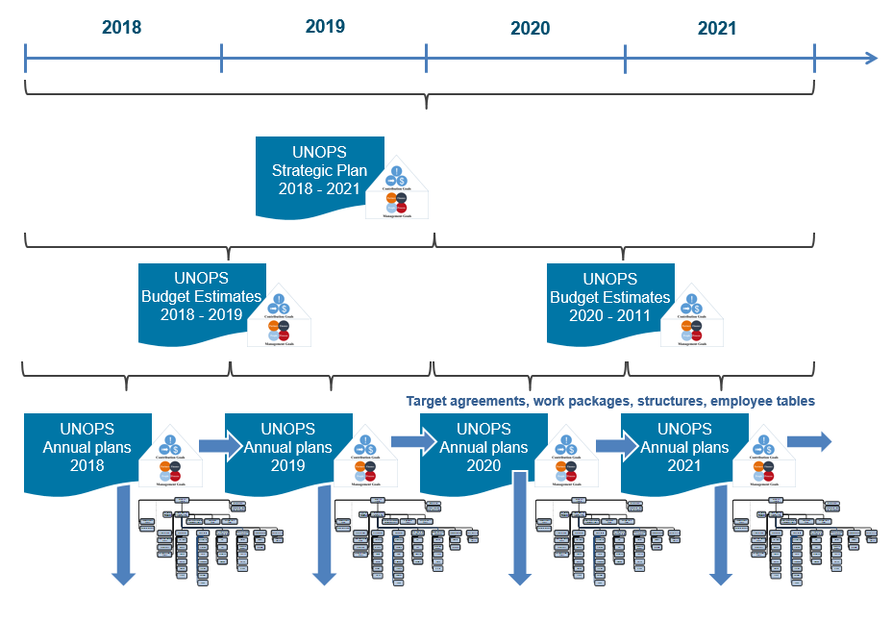

C. UNOPS global functions
4. UNOPS has developed its budget for the biennium 2018-2019 in alignment with the harmonized approach adopted by UNDP, UNFPA and UNICEF based on decisions 2010/32, 2011/10, 2012/27 and 2013/9, in which the Executive Board approved harmonized approaches for cost classification, results-based budgeting and budget presentation. The harmonized approach includes presentation of the budget in line with seven harmonized functional clusters. In continuation of the budget estimates for the biennium 2012-2013 to 2016-20175, UNOPS deploys a more granular functional framework internally and describes 14 global functions traceable to the seven harmonized functional clusters:
Figure 2: UNOPS global functions mapped to harmonized functional clusters
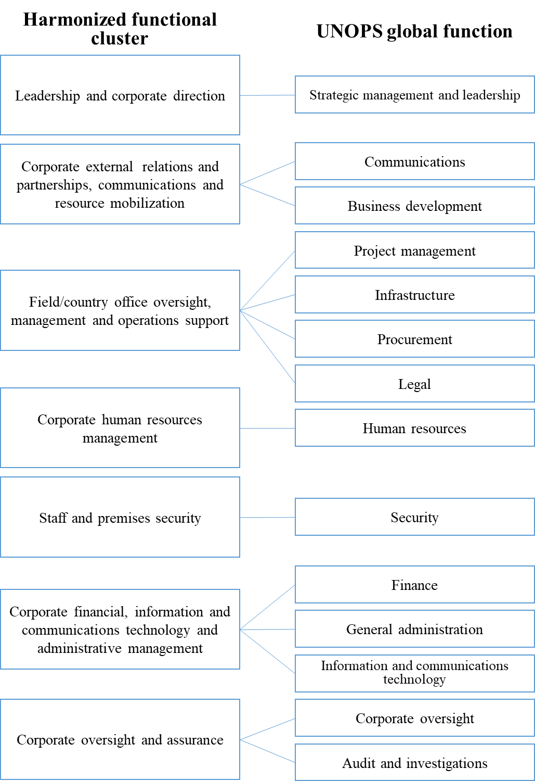
Strategic management and leadership
7. The global function ‘Strategic management and leadership’ includes responsibility to:
(a) Develop, champion and act as a role model for the UNOPS mission, vision, values and ethics;
(b) Set strategy based on understanding the needs and expectations of stakeholders and the external environment, and on an understanding of internal performance capabilities;
(c) Provide strategic direction and authoritative advice on corporate priorities and ensure appropriate structural arrangements within and between entities in the global structure;
(d) Oversee organizational and/or project portfolio performance, and execute appropriate controls;
(e) Advise on development, review and updating of relevant policies;
(f) Advise on implementation, communication and monitoring of relevant policies;
(g) Engage with external stakeholders, including United Nations coordination.

Project management
8. The global function ‘project management’ includes responsibility to:
(a) Enable timely delivery of successful projects and programmes in accordance with the UNOPS project management methodology, which ensures that quality, speed and results are of the highest standards;
(b) Advance project management practices, including through the use of tools for community engagement, integration of gender equality; and contribute to national capacity development;
(c) Identify and develop opportunities for the provision of project management services for partners;
(d) Support project management as the primary modality of delivery for UNOPS, externally and internally;
(e) Enable and distribute efficient and effective provision of support and advice to users and external partners, while ensuring adequate controls;
(f) Within the field of project management, provide and deliver best practice examples, tools, guidance and oversight of projects and project portfolios.

Infrastructure
9. The global function ‘Infrastructure’ includes responsibility to:
(a) Enable timely delivery of successful infrastructure projects in which the quality, speed and results are of the highest standards;
(b) Advance infrastructure practices, including through integrating resilience and climate change adaption elements, and contribute to national capacity development;
(c) Identify and develop opportunities for the provision of infrastructure services for partners;
(d) Ensure that the organization’s products and services are developed to create optimum value for partners and beneficiaries and are produced, delivered and managed using sustainable approaches;
(e) Enable and distribute efficient, effective provision of support and advice to users and external partners, while ensuring adequate controls;
(f) Within the field of infrastructure, provide and deliver best practice examples, tools, guidance and oversight of infrastructure projects.
Procurement
10. The global function ‘Procurement’ includes responsibility to:
(a) Enable the organization to procure goods and services in a transparent, accountable and efficient manner in order to execute the UNOPS business strategy;
(b) Advance procurement practices, including through sourcing strategies chains and considerations of product life-cycles, and contribute to national capacity development;
(c) Identify and develop opportunities for the provision of procurement services for partners;
(d) Ensure that UNOPS products and services are developed to create optimum value for partners and beneficiaries, and are produced, delivered and managed using sustainable approaches;
(e) Enable and distribute efficient, effective support and advice to users and external partners, while ensuring adequate controls;
(f) Within the field of procurement, provide and deliver best practice examples, tools, guidance and oversight of procurement and procurement projects.

Communications
11. The global function ‘Communications’ includes responsibility to:
(a) Develop communications strategies, policies, plans and channels based on communications needs and expectations;
(b) Maintain and strengthen the UNOPS corporate identity through unifying internal and external communications, enabling accountability and transparency;
(c) Communicate clear direction and strategic focus, ensuring that the people of UNOPS understand and can demonstrate their contribution to its success;
(d) Facilitate and encourage the sharing of information, knowledge and best practices, achieving dialogue throughout the organization.

Business development
12. The global function ‘Business development’ includes responsibility to:
(a) Establish and deepen strategic partnerships in support of the development of new engagements, and facilitate coordinated, systematic approaches to business partner and client relations management, for mutual, sustainable benefit;
(b) Ensure greater collaboration and coordination with key partners, including through the establishment of liaison offices to engage on current projects and future priorities, and for knowledge-sharing;
(c) Ensure that UNOPS products and services are promoted and marketed effectively, and that partner relationships are managed and strengthened;
(d) Manage UNOPS knowledge partners for sustainable benefits for the organization and its partners;
(e) Within the field of business development, provide and deliver best practice examples, tools, guidance and oversight of partner relations and engagements.

Finance
13. The global function ‘Finance’ includes responsibility to:
(a) Steward the resources of the organization, ensuring cost recovery, financial resilience and accurate financial reporting to partners and clients;
(b) Advance development effectiveness, including through further attribution of direct cost for shared services as appropriate;
(c) Maintain appropriate controls and integrity of financial management, in accordance with relevant international standards;
(d) Enable and distribute efficient, effective support and advice to users and external partners, while ensuring adequate controls (in reporting, for example);
(e) Within the field of finance, provide and deliver best practice examples, tools, guidance and oversight of finance processes.
(f) Ensure effective and efficient planning of management budget and results
(g) Maintain appropriate review mechanism for financial and non-financial results, on quarterly and annual basis

Human resources
14. The global function ‘Human resources’ includes responsibility to:
(a) Enable UNOPS to recruit, develop and retain a talented workforce with the skills and competencies to execute its business strategy;
(b) Ensure that UNOPS personnel are aligned, including through linking standardized profiles and job descriptions to organizational structures, processes and products and services;
(c) Promote a culture that allows the mutually beneficial achievement of organizational and personnel goals, by caring, communicating, rewarding and recognizing, in a way that motivates UNOPS people, builds commitment, and enables them to use their skills and knowledge for the benefit of the organization;
(d) Promote fairness, equality and diversity, including gender parity;
(e) Enable and distribute efficient and effective provision of support and advice to users and external partners while ensuring adequate controls (with regards to individual contractor agreements, for example);
(f) Within the field of human resources, provide and deliver best practice examples, tools, guidance and oversight of human resources processes.
(g) Drive and support world-class performance and continuous improvement, and nurture a high-performance management culture, ensuring that the organization is flexible and manages change effectively; add risk
(h) Advise on and drive cross-functional integration and coordination within the organization;

Legal
15. The global function ‘Legal’ includes responsibility to:
(a) Enable the UNOPS legal and contracting activities to execute its business strategy, ensuring that its legal commitments reflect the UNOPS vision, values and ethics;
(b) Enable and distribute efficient, effective support and advice to users and external partners, while ensuring adequate controls.
General administration
16. The corporate function ‘General administration’ includes responsibility to:
(a) Facilitate the provision of premises, facilities and support services that are functional, cost-effective and sustainable;
(b) Optimize the use, and effectively manage the life-cycle and physical security, of buildings, equipment and materials;
(c) Establish safe, timely and cost-effective travel arrangements;
(d) Establish and implement realistic, effective and efficient business continuity and disaster recovery plans;
(e) Establish and implement policy for records retention and management;
(f) Facilitate host country liaison.

Information and communications technology
17. The corporate function ‘Information and communications technology’ includes responsibility to:
(a) Manage information and communications technology to support the delivery of UNOPS strategy;
(b) Manage the technology portfolio by optimizing use of existing technology and replacing outdated technology;
(c) Evaluate and develop the technology portfolio to improve the agility of UNOPS and its processes and projects;
(d) Involve relevant stakeholders in the development and deployment of new technologies to maximize benefits generated;
(e) Use technology to support the UNOPS culture of creativity and innovation;
(f) Aid and advise on transforming data into information, and facilitate distribution of timely, accurate, strategic and tactical management decision support.

Security
18. The global function ‘Security’ includes responsibility to:
(a) Provide UNOPS internal entities with advice, guidance and technical assistance regarding health, safety, environmental and security throughout its global responsibilities;
(b) Consistently provide managers and personnel with the necessary information and tools concerning the day-to-day management of health, safety, environmental and security risks;
(c) Provide instructions to support health, safety, environmental and security decision-making and to escalate decisions with regional or organization-wide impact to the Executive Director;
(d) Strengthen and make more explicit the overall safety and security framework, culture, and roles and responsibilities within the organization to allow justified, measured approaches and responses to health, safety, environmental and security management practices globally.

Corporate Oversight
19. The global function ‘Corporate Oversight’ includes responsibility to:
(a) Ensure that UNOPS is able to gather and aggregate risk related information at all organisational levels
(b) Ensure that UNOPS projects are regularly assessed against cost and time targets
(c) Ensure that proposed procurement actions are in accordance with UNOPS financial regulations and rules, policies, and instructions;
(d) Review the procurement process to ensure that it is fair, competitive, and transparent, provides best value for money, and represents best practices and commonly accepted practices of United Nations procurement.

Audit and investigations
20. The corporate function ‘Audit and investigations’ includes responsibility to:
(a) Provide independent, impartial assurance and advice designed to improve UNOPS operations;
(b) Lead the Executive Director’s investigations into alleged fraud, corruption, waste of resources, abuse of authority or other misconduct or violations of UNOPS regulations, rules and administrative instructions;
(c) Help the organization achieve its objectives through a systematic approach designed to evaluate and enhance the effectiveness of risk management, control and governance processes.

Annex II. Terminology

Activity-based costing: Cost accounting method that identifies activties in an organization and assigns organizational cost based on the resource consumption of the different activities.
Advisory services: Contributing to increased national capacity and ownership through advice to partners on best management practices, standards, systems and processes, and related training, in UNOPS-mandated focus areas.
Global function: An area of specialized expertise within UNOPS. The totality of personnel associated with a global function is refered to as a practice, which transcends entities in global structure of the organization. All the practices are insititutionally anchored at UNOPS headquarters.
Cost driver: In activity-based costing, activities that affect costs are defined as ‘cost drivers’. UNOPS uses cost drivers as fair proxy to link costs charged to resource consumption.
Cost increase/decrease: Any increase or decrease in the cost of a resource input in the budget period compared with that in the previous budget period, arising from inflation and changes in exchange rates.
Delivery platform: The ability to serve partners through the integration of existing processes, information and communications technology systems, and locations. The delivery platform, as backbone to UNOPS activities, seeks to achieve scale, cost savings, and the global reach of UNOPS activities without replicating operational setups in each location where UNOPS is active.
Delivery or delivery volume: Project expenditure, excluding fees.
Direct cost: Costs incurred for the benefit of a particular project or client(s). Such costs are readily identifiable as having direct benefit for a particular project or client(s), and can be clearly documented. Direct costs are not covered by the management fee.
Enterprise resource planning: A management information system that integrates and automates business practices associated with the operations of an organization; or multi-module application software that helps an organization to support such systems; or a combination of the above.
Harmonized functional cluster: Part of the harmonized approach adopted by UNDP, UNFPA and UNICEF in which UNOPS submits its budget estimates. UNOPS global functions can be mapped to the seven harmonized functional clusters.
Indirect cost: Costs incurred by the management and administration of the organization in furtherance of UNOPS activities and policies. Such costs are charged to projects through a management fee specified in the project agreement.
Individual contractor agreement (known as an ‘ICA’): A UNOPS legal instrument governed solely by its expressed terms and conditions, including the terms of reference and general conditions for such agreements as determined by UNOPS policy. The individual contractor agreement is used to retain the services of a person engaged in his/her individual capacity to perform a specific task or deliver a defined piece of work within specific project-based deliverables of time-limited nature.
Key Performance indicator (KPI): A quantitative expression of level of ambition, providing a gauge for the extent to which a goal is achieved. A performance indicator is typically expressed with a baseline (performance at the beginning of a given period) and a target (level of ambition for performance at the end of that period). The indications of results achieved at a given point in time are typically referred to as ‘actuals’. Results derived from performance against an indicator may express the extent to which a quantiative goal is achieved, or be used to substantiate a qualitative expression of goal achievement.
Liabilities: All present commitments of UNOPS arising from past events, the settlement of which is expected to result in an outflow from UNOPS of resources embodying economic benefits or service potential.
Management budget/resources: UNOPS budget estimates in support of the management results framework, that is, budget estimates excluding net revenue target and earmarking for potential provisions.
Management results: The UNOPS management results framework is based on its four management goals: recognized value; financial stewardship; process excellence; and people excellence. The four management goals provide direction to how UNOPS ensures the viability of its self-financing business model, and reflect the four perspectives (partners; business process; people; and finance) of the UNOPS balanced scorecard, a core management tool used to drive performance and maturity at all levels of the organization by means of performance indicators and associated targets.
Net revenue: The difference between gross revenue and expenses.
Net surplus/deficit: Comprises the following components: (a) surplus or deficit from ordinary activities; and (b) extraordinary items.
Operational reserves: The reserve established at the level set by the Executive Board with the aim of guaranteeing the financial viability and integrity of UNOPS as a going concern.
Self-financing: Generating its capital from its own revenue, instead of acquiring it from external sources.
Transactional support services: Specific services, in the United Nations context typically associated with common or shared services, where partners avail themselves of the UNOPS delivery platform. These services are limited to identifiable, specific transactions in areas such as procurement and human resources.
Volume increase/decrease: Any increase or decrease in resource requirements attributable to changes in the level or nature of activities carried out by an organization during the current budget period and those proposed for the forthcoming budget period.
Write-offs or writing off: The cancellation of a bad debt or worthless asset from a UNOPS account or project account; the act of cancelling such a debt or asset.

______________

Data for measure derived from the UNOPS results-based reporting tool.
Data for measure derived from the UNOPS results-based reporting tool.
Data for measure derived from the UNOPS results-based reporting tool.
Reported as share on UNOPS ongoing projects that have adopted UNOPS Enterprise Project Management tool, including a standardized project plan and risk registry.
Data for measure derived from the UNOPS Partner Survey and calculated as share of respondents who indicate that they are ‘satisfied’ or ‘very satisfied’ with UNOPS, or services received from UNOPS.
Net Promoter Score is calculated as Promotor % (score 9-10) minus Detractors % (score 0-6) for the question on likelihood to recommend UNOPS services in UNOPS Partner Survey. The minimum score for the indicator is -100% and maximum score is 100%.
Share of UNOPS offices (including headquarters) that are participating in common procurement groups with other UN agencies
IATI = International Aid Transparency Initiative
Results calculated as average number of individual visits (sessions) per month to the UNOPS public website (www.unops.org).
Covering content on www.unops.org, but excluding time sensitive, country specific announcements, and content on www.data.unops.org and www.gprs.unops.org, which are available as English language versions only.
Personnel engagement” will be measured through UNOPS’ people survey, which was launched for the first time in 2016 and replaced the previously conducted personnel satisfaction survey. Target is based on benchmark from high performing organizations.
Direct learning expenditure includes: learning and development personnel costs (including their travel costs), cost of administration, non-personnel development costs, learning delivery costs (i.e. classroom facilities, online learning technology infrastructure), outsourced activities, and tuition reimbursement (as defined by Association for Talent Development (ATD) industry reports).
EFQM define the Leadership criterion as: “Excellent Organizations have leaders who shape the future and make it happen, acting as role models for its values and ethics and inspire trust at all times. They are flexible, enabling the organization to anticipate and react in a timely manner to ensure the ongoing success of the organization.” UNOPS has been assessed against this criterion in 2017 which establishes the baseline.
Data for measure derived from completion rates of UNOPS quarterly assurance process for partner projects, put in place to manage risk and assure that engagements are performing successfully and contributing to objectives.
UNOPS target period for the operational closure of projects is six months.
Certifications refer to the standards ISO 9001 for Quality Management, ISO 14001 for Environmental Management and OHSAS 18001 for Health and Safety Management.
Results calculated in accordance with method used by UNOPS Internal Audit and Investigations Group, as overall implementation of audit recommendations issued from 2008.

